

A CAPSTONE PROJECT REPORT
ON
PET HUB
AN INTEGRATED PET CARE, ADOPTION, AND LOST & FOUND MANAGEMENT PORTAL

Submitted in partial fulfilment of the requirements for the course
to the award of the degree of
BACHELOR OF TECHNOLOGY IN
INFORMATION TECHNOLOGY
Submitted by
192521241-D.PADMA SREE
192521162 - M.HASHETHA
192521076 - SWETHA S
Under the Supervision of
P.SURESH
SEPTEMBER 2026
SIMATS ENGINEERING
Saveetha Institute of Medical and Technical Sciences
Chennai-602105

SIMATS ENGINEERING
Saveetha Institute of Medical and Technical Sciences
Chennai – 602105
BONAFIDE CERTIFICATE
This is to certify that the Capstone Project entitled “Design and Development of an Integrated Pet Care, Adoption, and Lost & Found Management Portal” has been carried out by 192521241-D.PADMA SREE, 192521162 - M.HASHETHA ,192521076 - SWETHA Sunder the supervision of Guide Name and is submitted in partial fulfilment of the requirements for the current semester of the B.Tech Information Technology program at Saveetha Institute of Medical and Technical Sciences, Chennai.

COURSE COORDINATOR | COURSE FACULTY
Title / Name, Designation  Department / Branch  SIMATS Engineering, SIMATS, Chennai – 602105. | Title / Name, Designation  Department / Branch  SIMATS Engineering, SIMATS, Chennai – 602105.


SIMATS ENGINEERING
Saveetha Institute of Medical and Technical Sciences
Chennai – 602105
DECLARATION
We,D.PADMA SREE(192521241) of the Department of Information Technology, SIMATS Engineering, Saveetha Institute of Medical and Technical Sciences, Chennai, hereby declare that the Capstone Project Work entitled “Design and Development of an Integrated Pet Care, Adoption, and Lost & Found Management Portal” is the result of our own bonafide efforts. To the best of our knowledge, the work presented herein is original, accurate, and has been carried out in accordance with the principles of engineering ethics and academic integrity. All sources, references, data, software resources, and other materials used in the project have been appropriately acknowledged.
We further declare that the data, results, analysis, and findings presented in this report have not been fabricated, falsified, or manipulated. Any external tools, datasets, computational resources, open-source libraries, or AI-assisted tools used during the project have been appropriately disclosed. We confirm that all applicable ethical, academic, institutional, and professional requirements have been followed throughout the planning, development, testing, and documentation of the project.
Place: ____________
Date: ____________
Signature of Students with Names
D.PADMA SREE(192521241)


SIMATS ENGINEERING
Saveetha Institute of Medical and Technical Sciences
Chennai – 602105
INDIVIDUAL CONTRIBUTION STATEMENT
Student Name / Reg. No. | Specific Responsibilities | Design & Development Contribution | Testing & Analysis Contribution | Report Contribution | Approx. %
Swetha S – 192521076 | UI design, Pet Care & Health module | Frontend pages, forms and navigation | Functional and usability testing | Chapters 1, 3 and 4 | 50%
M Hashetha – 192521162 | Adoption & Lost and Found modules | Backend, database and workflows | Integration and system testing | Chapters 2, 4 and 5 | 50%
Total |  |  |  |  | 100%

ACKNOWLEDGEMENT
We express our sincere gratitude to SIMATS Engineering, Saveetha Institute of Medical and Technical Sciences, Chennai, for providing us with the opportunity, facilities, and academic environment to successfully complete our capstone project entitled “Design and Development of an Integrated Pet Care, Adoption, and Lost & Found Management Portal.”
We would like to express our heartfelt thanks to our Project Guide, Guide Name, Designation, for providing valuable guidance, continuous support, constructive suggestions, and encouragement throughout the planning, design, development, testing, and documentation of this project.
We extend our sincere thanks to the Course Coordinator and Course Faculty of the Department of Information Technology for their valuable academic support, technical guidance, and motivation during the course of this project.
We are also grateful to the faculty members and technical staff of SIMATS Engineering for providing the necessary laboratory facilities, resources, and technical assistance required to carry out the project successfully.
We thank our parents, friends, and classmates for their constant encouragement, support, and motivation throughout the project work. Their suggestions and assistance helped us overcome various challenges during the development and testing phases.
Finally, we thank everyone who directly or indirectly contributed to the successful completion of this capstone project. This project provided us with valuable practical experience in software development, database management, system design, testing, teamwork, and engineering problem-solving.

ABSTRACT

The Design and Development of an Integrated Pet Care, Adoption, and Lost & Found Management Portal addresses the difficulty of managing pet-related services through disconnected applications, informal social-media posts, and manual records. Pet owners may struggle to maintain health information, while shelters and potential adopters often face difficulties in sharing reliable pet profiles and tracking adoption requests. Lost and found cases are also time-sensitive and can be difficult to coordinate when information is distributed across multiple channels.
The proposed system is a centralized web-based portal that integrates three major functions: Pet Care & Health Management, Pet Adoption Management, and Lost & Found Management. Module 1 maintains pet profiles, vaccination details, medical records, reminders, and basic health-related information. The adoption module enables authorized users or organizations to publish pet profiles and allows interested users to submit adoption requests. The lost and found module provides structured reporting of missing and found pets using descriptions, photographs, location information, and status updates.
The system is designed using a modular software architecture with a database layer for persistent records and a responsive user interface for accessibility. Authentication and role-based access control are included to protect user and pet information. The development process includes requirement analysis, database design, interface development, module integration, functional testing, usability testing, and performance evaluation. The expected outcome is a practical, scalable, and user-friendly portal that improves information availability, reduces duplication of records, supports responsible pet ownership, and helps connect pets with appropriate care, adoption, or reunification opportunities.
Keywords: Pet Care, Pet Adoption, Lost and Found, Web Portal, Pet Health Records, Database Management

TABLE OF CONTENTS

S.NO | TITLE | PAGE.NO
1 | Certificate from the Supervisor | 1
2 | Declaration by the Candidate | 3
3 | Individual Contribution Statement | 5
4 | Abstract | 7
5 | List of Figures | 8
6 | List of Tables | 10
7 | List of Abbreviations | 12
8 | Chapter 1: Introduction and Engineering Problem | 14
9 | Chapter 2: Literature Review and Existing Solutions | 16
10 | Chapter 3: Engineering Design & Trade-offs, Sustainability, Ethics, Safety, Risk & Security | 19
11 | Chapter 4: Implementation, Testing & Results, Project Management | 20
12 | Chapter 5: Conclusion, Future Work and Reflection | 22
13 | References | 25
14 | Appendices | 27

LIST OF FIGURES
Figure No. | Figure Name | Page No.
3.1 | Overall System Architecture | 30
3.2 | System Workflow / Data Flow | 31
4.1 | Pet Care Module Interface | 34_
4.2 | Adoption Workflow | ___
4.3 | Lost & Found Interface | ___
4.4 | Testing / Results Graph | ___

LIST OF TABLES
Table No. | Table Name | Page No.
3.1 | Stakeholder Requirements | ___
3.2 | Functional and Non-Functional Requirements | ___
3.3 | Design Specifications | ___
3.4 | Alternative Evaluation Matrix | ___
3.5 | Risk Register | ___
4.1 | Test Plan and Verification | ___
4.2 | Objective Achievement | ___
4.3 | Project Budget | ___

LIST OF ABBREVIATIONS / SYMBOLS
Symbol / Abbreviation | Description | Unit
UI | User Interface | -
UX | User Experience | -
DB | Database | -
API | Application Programming Interface | -
CRUD | Create, Read, Update, Delete | -
RBAC | Role-Based Access Control | -
URL | Uniform Resource Locator | -

CHAPTER 1: INTRODUCTION AND ENGINEERING PROBLEM

1.1 Background
Pet care and animal welfare services increasingly depend on digital information systems for storing records, sharing pet information, and coordinating services. However, pet health information, adoption listings, and lost-and-found reports are frequently maintained in separate systems or informal communication channels. This fragmentation can result in incomplete records, repeated data entry, delayed communication, and difficulty tracking the current status of a pet.
The proposed project develops an integrated portal that brings these related activities into one structured platform. The system supports pet owners, adopters, shelters or animal welfare organizations, and administrators through role-based features. The design focuses on accessibility, data consistency, privacy, maintainability, and reliable status tracking.

1.2 Need for the Project
The project is needed because users require a single location to maintain pet information and respond quickly to adoption or lost-and-found situations. Existing approaches may depend on social-media posts, spreadsheets, paper records, or multiple unrelated applications. These approaches can make it difficult to verify information, update records consistently, and search for relevant cases. From an engineering perspective, the project provides an opportunity to integrate database management, authentication, search, notification workflows, responsive UI design, and system testing in one application.

1.3 Problem Statement
There is a need for a centralized and reliable software system that can manage pet health information, adoption listings and requests, and lost-and-found cases while maintaining data consistency, access control, usability, and timely status updates. The system must support multiple user roles and interacting workflows under practical constraints such as limited development resources, privacy requirements, data quality, and the need for a simple user experience.

1.4 Project Aim
To design and develop an integrated web-based portal that provides centralized pet care and health management, pet adoption coordination, and lost-and-found pet management.

1.5 Project Objectives
• To design a secure user registration, login, and role-based access mechanism.
• To develop a Pet Care & Health Management module for maintaining pet profiles, vaccination details, medical records, and reminders.
• To develop an adoption management workflow for publishing pet profiles, searching available pets, and handling adoption requests.
• To develop a lost-and-found management workflow for reporting missing or found pets and tracking case status.
• To design a centralized database that maintains consistent user, pet, health, adoption, and case information.
• To test the integrated system for functionality, usability, reliability, and performance.

1.6 Scope
Included: user management, pet profiles, health records, vaccination information, adoption listings and requests, lost-and-found reports, search/filtering, status updates, administrator functions, database storage, and system testing.
Excluded: professional veterinary diagnosis, emergency medical treatment, physical shelter operations, guaranteed pet identification, and direct legal ownership verification. The system provides information-management support and does not replace veterinary or animal-welfare professionals.
Assumptions include internet availability, user-provided information being reasonably accurate, authorized access to protected functions, and availability of required hosting/database resources.

1.7 Expected Engineering Outcome
The expected outcome is a functional prototype web portal with integrated modules, a structured relational database, responsive user interfaces, role-based access control, searchable records, and tested workflows for pet care, adoption, and lost-and-found management.

CHAPTER 2: LITERATURE REVIEW AND EXISTING SOLUTIONS

2.1 Review Method
Relevant work can be identified through academic databases, software documentation, animal-welfare technology resources, and existing pet-management platforms. The review should focus on digital pet health records, adoption management systems, missing-pet reporting, database-driven portals, authentication, privacy, and user-interface design.

2.2 Review of Existing Work
Existing pet-management applications generally focus on one or two functions, such as health tracking, adoption listings, or community reporting. Health-oriented applications commonly provide pet profiles and reminders, while adoption platforms emphasize searchable listings and communication between organizations and adopters. Lost-pet services typically provide location-based reporting and community alerts. These approaches demonstrate the value of digital records but also reveal opportunities for integrating related workflows into one platform.

2.3 Comparative Analysis
Existing Approach | Advantages | Limitations | Relevance
Manual / paper records | Simple and inexpensive | Difficult to search, update and share | Shows need for digital records
Social-media reporting | Fast community reach | Unstructured data, difficult tracking | Useful for awareness but weak for structured case management
Single-purpose pet apps | Focused functionality | Limited integration across services | Provides design ideas for individual modules
Proposed integrated portal | Centralized data and workflows | Requires development, maintenance and user adoption | Addresses integration gap

2.4 Research / Engineering Gap
A practical gap exists between separate pet-care, adoption, and lost-and-found workflows. Information may need to be entered repeatedly, and the status of a pet may not be synchronized across activities. The proposed system addresses this engineering gap by using shared pet and user records with connected workflows.

2.5 Proposed Contribution
The project contributes an integrated database-driven portal that connects pet health information, adoption management, and lost-and-found reporting. The design emphasizes modularity, role-based access, structured data, searchable records, and clear status transitions.

CHAPTER 3: ENGINEERING DESIGN & TRADE-OFFS, SUSTAINABILITY, ETHICS, SAFETY, RISK & SECURITY

3.1 Requirements
Stakeholder / User | Requirement
Pet Owner | Create and manage pet profile and health information; receive reminders.
Adopter | Search available pets, view details, and submit adoption requests.
Shelter / Welfare Organization | Publish adoption profiles and manage requests.
Lost & Found Reporter | Report missing/found pets and update case information.
Administrator | Manage users, records, reports, and system-level settings.
Requirement Type | Measurable Target
Functional | Core workflows complete successfully in system testing.
Functional | Users can create, view, update and manage permitted records.
Non-Functional | Responsive interface across common desktop/mobile screen sizes.
Non-Functional | Role-based access prevents unauthorized management functions.
Non-Functional | Database maintains referential and validation constraints.

3.2 Constraints & Applicable Standards
Standard / Code | Requirement | How Applied
OWASP Application Security Verification Standard (ASVS) | Web application security practices | Authentication, access control, input validation and secure data handling are considered.
ISO/IEC 25010 | Software product quality model | Functionality, usability, reliability, security and maintainability guide evaluation.
Institutional academic integrity requirements | Accurate attribution and ethical project reporting | Sources, software, datasets and AI-assisted resources are acknowledged.

3.3 Design Specifications
Parameter | Target / Requirement | Unit | Priority
User authentication | Secure login and role control | system feature | High
Pet profile | Name, species, breed, age, gender and image/details | record | High
Health record | Vaccination and medical-history fields | record | High
Adoption workflow | Listing → request → review → status | workflow | High
Lost & found workflow | Report → search/match support → status update | workflow | High
Database | Centralized relational storage | database | High
UI | Responsive and easy to navigate | interface | High

3.4 Alternative Solutions & Evaluation
Alternative 1: Separate mini-applications for pet care, adoption, and lost-and-found. This approach is simple to develop initially but requires users to manage multiple systems.
Alternative 2: A centralized integrated web portal. This approach shares user and pet records across modules and provides a consistent workflow.
Criterion | Weight | Alternative 1 | Alternative 2
Performance | 25% | 3/5 | 4/5
Cost | 15% | 4/5 | 3/5
Safety | 15% | 3/5 | 4/5
Sustainability | 15% | 3/5 | 4/5
Reliability | 30% | 3/5 | 4/5

3.5 Selected Design & Detailed Design
The integrated web portal is selected because it provides stronger data consistency and workflow integration than separate applications. A centralized database allows shared pet and user information while role-based access controls limit who can create or modify sensitive records.
[Insert labelled system architecture diagram here: User Interface → Application Layer → Authentication/Business Logic → Database, with Pet Care, Adoption, Lost & Found and Administration modules.]
Systems approach: The user interface communicates with application services that validate requests and apply role permissions. The database stores user, pet, health, adoption, and lost-and-found information. Module-level workflows depend on shared pet and user identifiers, allowing information to remain consistent across the system.

3.6 Trade-off Analysis
Design Decision | Alternative Considered | Benefit | Disadvantage | Final Decision & Justification
Centralized database | Separate databases | Consistency and easier integration | Requires careful access control | Selected because shared records are central to the project.
Role-based access | Same access for all users | Improves security and accountability | Adds implementation complexity | Selected because different stakeholders require different permissions.
Responsive web interface | Desktop-only UI | Better accessibility | More UI testing required | Selected for broader usability.

3.7 Sustainability, Ethics, Safety, Risk & Security
Domain |  | Consideration |  | Evidence Evaluated |  | Impact on Final Decision
Sustainability |  | Digital records reduce dependence on paper-based records |  | Electronic storage and workflows |  | Centralized digital records selected
Ethics |  | Pet and user information must be handled responsibly |  | Data minimization and access rules |  | Only necessary information is collected
Health & Safety |  | Portal must not be presented as veterinary diagnosis |  | Module scope and user guidance |  | Health records are informational, not diagnostic
Security |  | Unauthorized access or false updates could harm users |  | Authentication, authorization and validation |  | RBAC and validation included
Risk | Likelihood |  | Severity | Risk Level | Mitigation |  | Residual Risk
Unauthorized account access | Medium |  | High | High | Strong passwords, authentication and session controls |  | Medium
Incorrect user-provided pet data | Medium |  | Medium | Medium | Validation, edit controls and admin review |  | Low-Medium
False lost/found report | Medium |  | High | High | Reporting controls and status verification |  | Medium
Data loss | Low |  | High | Medium | Regular backup strategy and database integrity checks |  | Low
System downtime | Low |  | Medium | Low-Medium | Monitoring and recovery procedures |  | Low

CHAPTER 4: IMPLEMENTATION, TESTING & RESULTS, PROJECT MANAGEMENT

4.1 Development Approach & Resources
An iterative development approach is suitable for the project. Requirements are first converted into modules and database entities, followed by interface development, backend implementation, integration, testing, and refinement. Each major module is tested independently before full-system integration. User feedback and test observations can be used to improve navigation, validation, and workflow clarity.
Resource | Purpose
Development computer | Software development and testing
Web development environment | Frontend and backend implementation
Relational database | Persistent storage of system records
Sample pet dataset | Functional and interface testing
Modern development tools / AI-assisted tools | Code assistance, debugging and documentation support where applicable

4.2 Hardware / Software / Fabrication Implementation & Modern Tools Used

Software Implementation
The portal can be implemented using a standard web technology stack such as HTML, CSS and JavaScript for the interface, a server-side framework for application logic, and a relational database for persistent storage. The exact technologies should be replaced with the tools actually used by the project team.
Tool / Software / Equipment | Purpose | Stage Used
VS Code / IDE | Source-code development | Development
HTML/CSS/JavaScript | Responsive user interface | Development
Backend framework | Business logic and API/service layer | Development
MySQL / relational DB | Data storage and queries | Development & Testing
Git / version control | Source-code tracking | Development
Browser developer tools | UI and debugging | Testing
[Insert screenshots of login page, dashboard, Pet Care module, Adoption module, Lost & Found module, database schema, and final implementation here.]

4.3 Test Plan & Verification
Requirement | Test Method | Specification / Required Value | Acceptance Criterion | Achieved Value
Login | Functional test | Valid user can log in | Dashboard opens for valid credentials | ___
Pet profile | CRUD test | Create/read/update permitted | Record saved and displayed correctly | ___
Health record | Validation test | Required fields validated | Invalid/incomplete input rejected | ___
Adoption request | Workflow test | Request status changes correctly | Authorized users can manage request | ___
Lost & found report | Functional test | Report can be created and updated | Case status displayed correctly | ___
Access control | Security test | Unauthorized role denied | Restricted page/action blocked | ___

4.4 Results
The final results should be presented using screenshots, tables, graphs, and test summaries. Recommended metrics include functional test pass percentage, average response time for selected operations, validation success rate, and user usability feedback.
Test Category | Total Tests | Passed | Failed | Pass %
Authentication | ___ | ___ | ___ | ___%
Pet Care | ___ | ___ | ___ | ___%
Adoption | ___ | ___ | ___ | ___%
Lost & Found | ___ | ___ | ___ | ___%
Security / Access Control | ___ | ___ | ___ | ___%

4.5 Data Analysis & Engineering Judgment
The test results should be analyzed to determine whether the system meets its specified requirements. Failed cases should be categorized by cause, such as validation errors, interface issues, database constraints, authorization problems, or integration defects. If response time or usability deviates from the target, the engineering implication should be stated and corrective actions documented.

4.6 Comparison with Existing Solutions & Achievement of Objectives
Objective | Evidence | Achievement
Secure user management | Authentication and role testing | Fully / Partially / Not Achieved
Pet Care module | Pet and health record screenshots/tests | Fully / Partially / Not Achieved
Adoption management | Listing and request workflow tests | Fully / Partially / Not Achieved
Lost & Found module | Report and status workflow tests | Fully / Partially / Not Achieved
Centralized database | Schema and CRUD test evidence | Fully / Partially / Not Achieved
System testing | Test summary and defect records | Fully / Partially / Not Achieved

4.7 Strengths & Limitations
Strengths:
• Integrated management of three related pet-service functions.
• Centralized records reduce duplicate data entry.
• Role-based workflows support different user responsibilities.
• Searchable and structured information improves usability.
• Modular design supports future feature expansion.
Limitations:
• Accuracy depends partly on information supplied by users or administrators.
• The portal does not provide professional veterinary diagnosis.
• Real-world pet identity verification may require external processes.
• Large-scale deployment would require additional security, monitoring, backup and infrastructure testing.
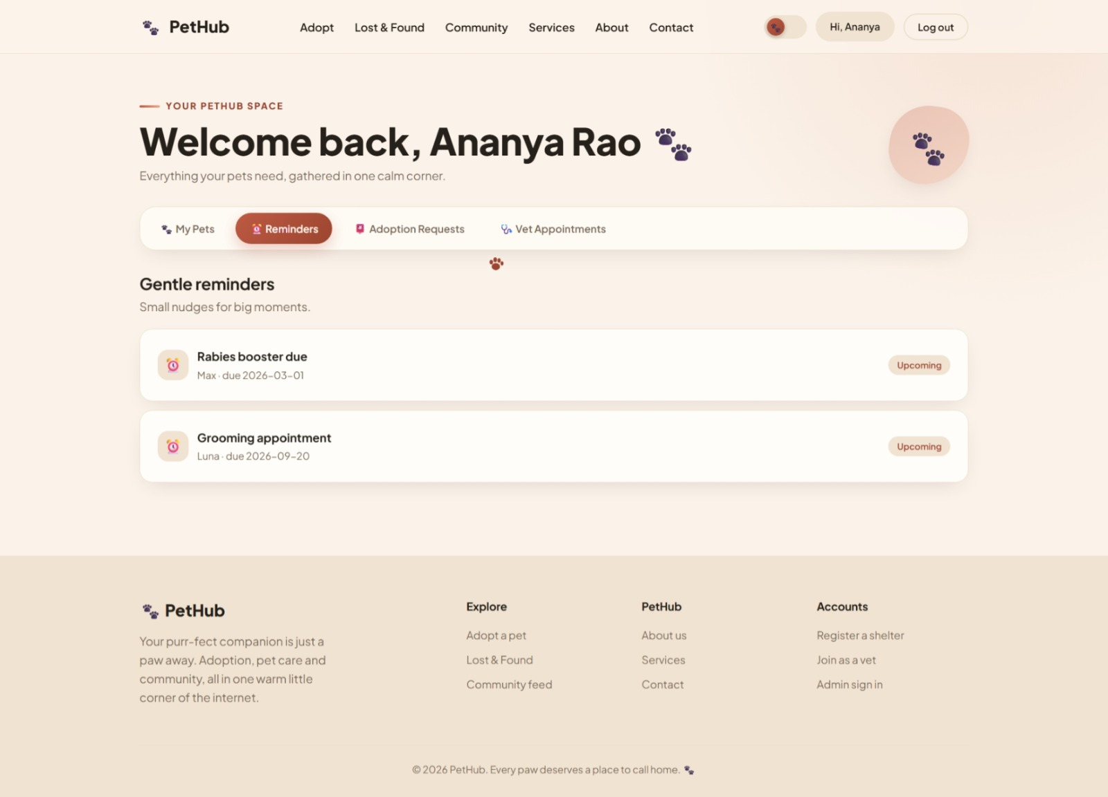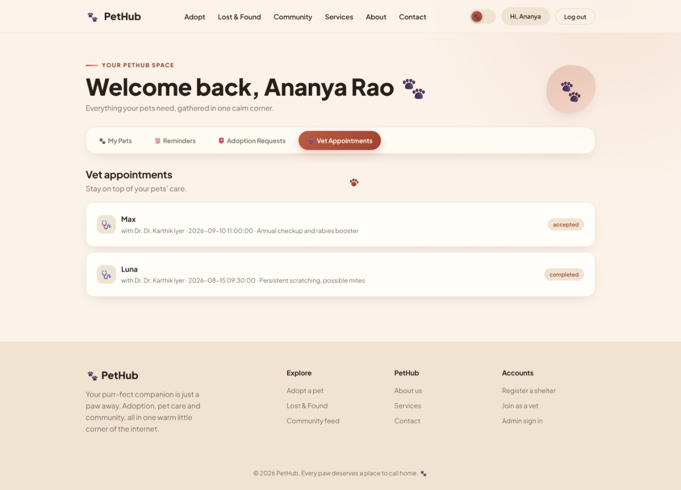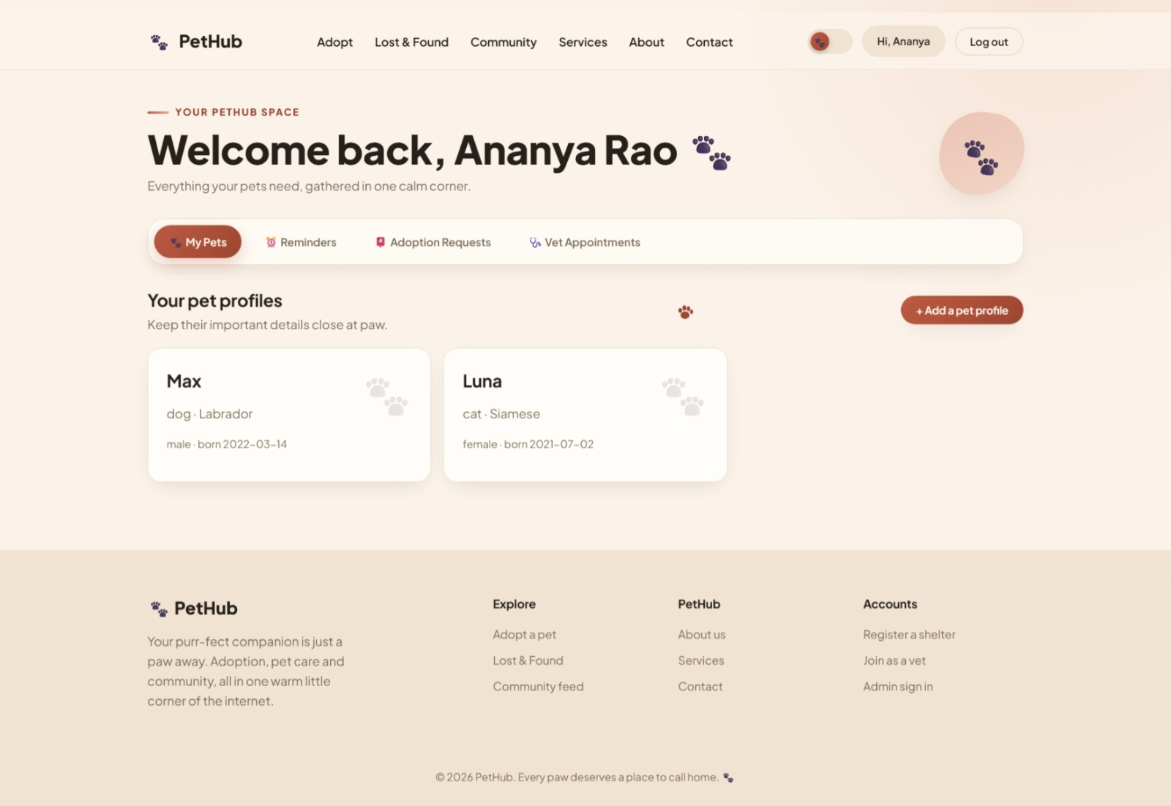
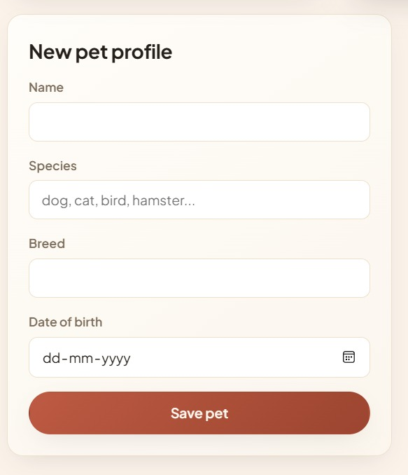

4.8 Project Planning, Roles & Budget
Milestone |  | Planned Activity |  |  | Status
1 |  | Requirement analysis |  |  | Completed / Pending
2 |  | Literature review |  |  | Completed / Pending
3 |  | Database and architecture design |  |  | Completed / Pending
4 |  | Module development |  |  | Completed / Pending
5 |  | Integration |  |  | Completed / Pending
6 |  | Testing and debugging |  |  | Completed / Pending
7 |  | Documentation and presentation |  |  | Completed / Pending
Student | Assigned Responsibility |  | Item / Resource | Estimated Cost |  | Actual Cost
Student 1 | UI and Pet Care module |  | Development / Internet / Testing | ₹___ |  | ₹___
Student 2 | Adoption, Lost & Found and database |  | Development / Internet / Testing | ₹___ |  | ₹___

CHAPTER 5: CONCLUSION, FUTURE WORK AND REFLECTION

5.1 Conclusion
The Design and Development of an Integrated Pet Care, Adoption, and Lost & Found Management Portal provides a centralized approach to managing important pet-related information and workflows. The system combines pet health records, adoption coordination, and lost-and-found reporting within a common platform. Its modular architecture, database-driven design, role-based access, and structured workflows are intended to improve information consistency, usability, and coordination.
Validation through functional, integration, usability, and security-oriented testing provides evidence for evaluating the project objectives. The resulting prototype demonstrates how software engineering principles can be applied to an animal-welfare-oriented information system while recognizing limitations related to data accuracy, professional medical advice, and real-world verification.

5.2 Future Work
• Mobile application support for Android and iOS.
• Location-based lost-and-found search and map integration.
• Automated notifications for adoption requests, vaccinations and case updates.
• Optional image-based pet similarity matching for lost-and-found assistance.
• Integration with veterinary clinics or animal-welfare organizations.
• Enhanced analytics dashboards for administrators.
• Cloud deployment with stronger monitoring, backup, privacy and scalability controls.

5.3 Professional Learning & Individual Reflection
New Knowledge Acquired:
• Database schema design and relationship modelling.
• Role-based authentication and authorization.
• Responsive web application development.
• Software testing and debugging techniques.
• Technical documentation and project management.
Engineering & Professional Skills Developed:
• Requirement analysis and system modelling.
• Problem solving and engineering decision-making.
• Team collaboration and task allocation.
• Testing, analysis and interpretation of results.
• Technical communication and report preparation.
Individual Reflection – Student 1: The most difficult engineering problem was integrating multiple workflows without duplicating data. This was addressed by designing shared user and pet entities and defining clear module boundaries. A key decision was to use role-based access so each stakeholder could access only relevant functions. I independently improved my understanding of database design, interface development and testing. If the project were repeated, I would plan automated testing earlier in the development cycle.
Individual Reflection – Student 2: The main challenge was ensuring that adoption and lost-and-found status changes remained consistent. The problem was addressed by defining explicit workflow states and testing each transition. A key engineering decision was to centralize records so that modules could use common pet identifiers. I developed new skills in backend logic, database integration and debugging. If repeated, I would add stronger notification and monitoring features from the beginning.

REFERENCES
[1] ISO/IEC 25010, Systems and software engineering — Systems and software Quality Requirements and Evaluation (SQuaRE) — Product quality model.
[2] OWASP Foundation, Application Security Verification Standard (ASVS).
[3] Relevant peer-reviewed research papers on digital pet health records, animal adoption systems, and lost-and-found management.
[4] Official documentation for the programming language, web framework, database system, libraries, and development tools actually used.
[5] Any datasets, websites, open-source resources, and AI-assisted resources actually used in the project.

APPENDICES

Appendix A – Detailed Calculations
Include database/storage calculations, performance calculations, response-time analysis, or other essential engineering calculations.

Appendix B – Engineering Drawings / Schematics
Include system architecture, ER diagram, data-flow diagram, UML diagrams, workflow diagrams and interface wireframes.

Appendix C – Source Code / Code Repository Information
Include only essential code excerpts. Maintain complete source code in the approved repository.

Appendix D – Datasheets
Include applicable technical datasheets for any hardware or external components used.

Appendix E – Experimental / Raw Data
Include detailed test logs, datasets, survey responses, and raw measurements.

Appendix F – Ethics / Institutional Approval
Include approvals or ethical documentation where applicable.

Appendix G – Project Meeting / Progress Records
Include milestone records, meeting notes and supervisor feedback.

Appendix H – User/Industry Feedback
Include structured feedback from users or relevant stakeholders where applicable.

Appendix I – Publications / Patents / Competitions / Product Outcomes
Include evidence where applicable.

Appendix J – Individual Contribution Evidence
Include task logs, commit records, screenshots, or other evidence of individual contributions.

CAPSTONE PROJECT OUTCOME MAPPING SHEET
Outcome / Area | Relevant Report Location | Evidence
Complex engineering problem formulation | Chapter 1 | Problem statement and objectives
Engineering design under constraints | Chapter 3 | Requirements, alternatives and trade-offs
Written/oral technical communication | Whole report + Viva | Report and presentation
Ethics and professional responsibility | Chapter 3.7 | Ethics, privacy and responsible use
Teamwork and leadership | Chapter 4.8 + Contribution Statement | Roles and project records
Experimentation, analysis and engineering judgment | Chapter 4.3–4.6 | Testing, results and analysis
Independent acquisition of new knowledge | Chapter 5.3 | Learning and reflection
Standards | Chapter 3.2 | Applicable standards
Sustainability and societal/environmental impact | Chapter 3.7 | Sustainability evaluation
Risk assessment and mitigation | Chapter 3.7 | Risk register
Security considerations | Chapter 3.7 | Authentication and access control
Integrated/system-level engineering | Chapter 3.5 | System architecture and module interfaces
Project planning and management | Chapter 4.8 | Milestones, roles and budget
Individual contribution | Contribution Statement + Chapter 4.8 | Contribution evidence

